**Arrays and Pointers Assignment**

Mandatory

1. What does the code below refer to? Extend the code and demonstrate the use of ptr to access the contents of a 2D array.

int (*ptr)[4];

[Refer the sample code in “array_ptr_simple.c”]

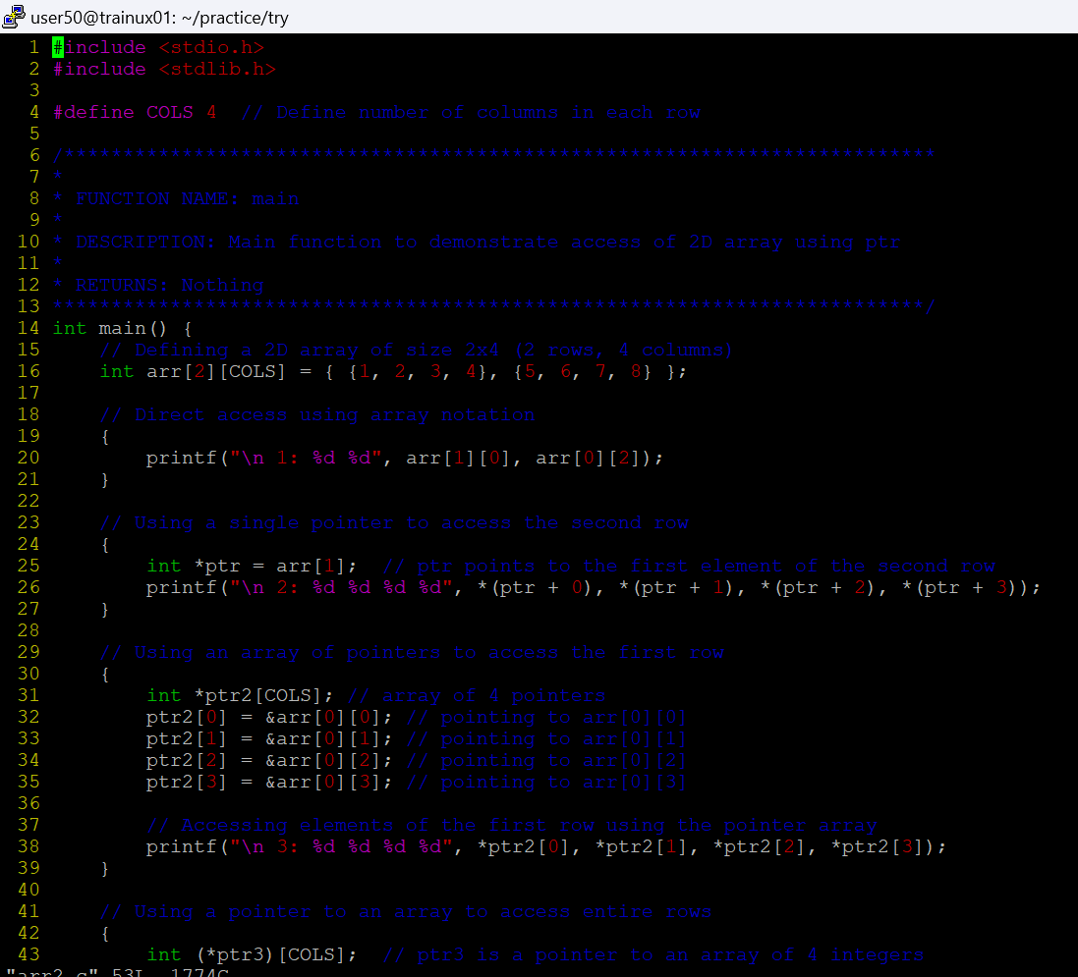

2. Refer the code in “array_ptr_simple_char.c”. Implement the missing functionality in the code marked with TBD1, TBD2…..

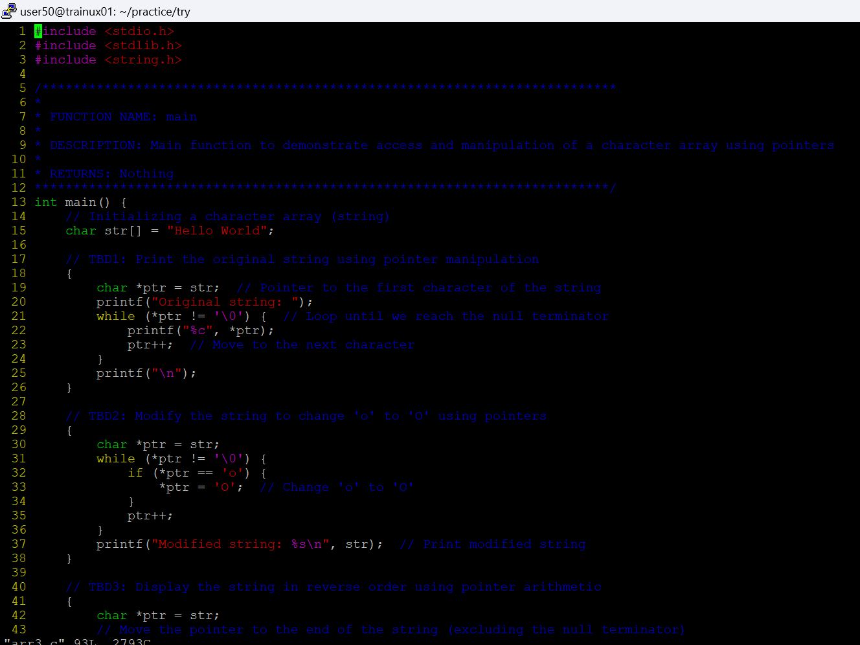

3. Refer the code snippet below. Implement the function search_insert() as mentioned in the code.

#define MAX 80

//search for the given char and if found, then create space for 1 character and insert ‘_’ after the searched character. Let the remaining characters in the input be placed after ‘_’.

int search_insert(char name[], char search_char);

int main()

{

char name[MAX]=”ABC”;

char *ptr = name;

int ret = search_insert(name, search_char);

if (ret == SUCCESS)

{

//display updated string

}

}

4. Refer the program “array_ptr_repr_partial.c”. Implement the functions below which are yet to be implemented in code.

int func1(int (*ptr)[3]); // pointer to array, second dimension is explicitly specified

int func2(int **ptr); // double pointer, using an auxiliary array of pointers

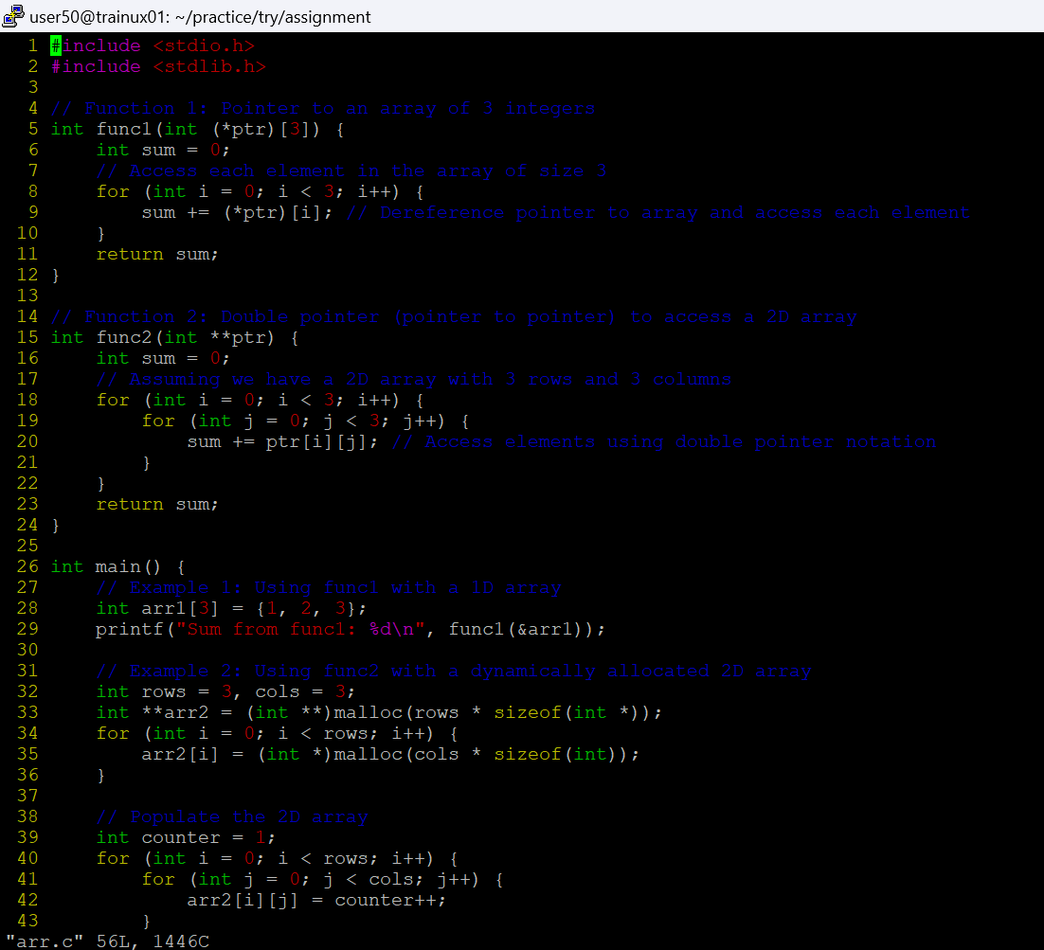

5. Refer the program “array_dbl_pointers_function_partial.c”. Implement the missing functionality in the code marked with TBD1, TBD2…..

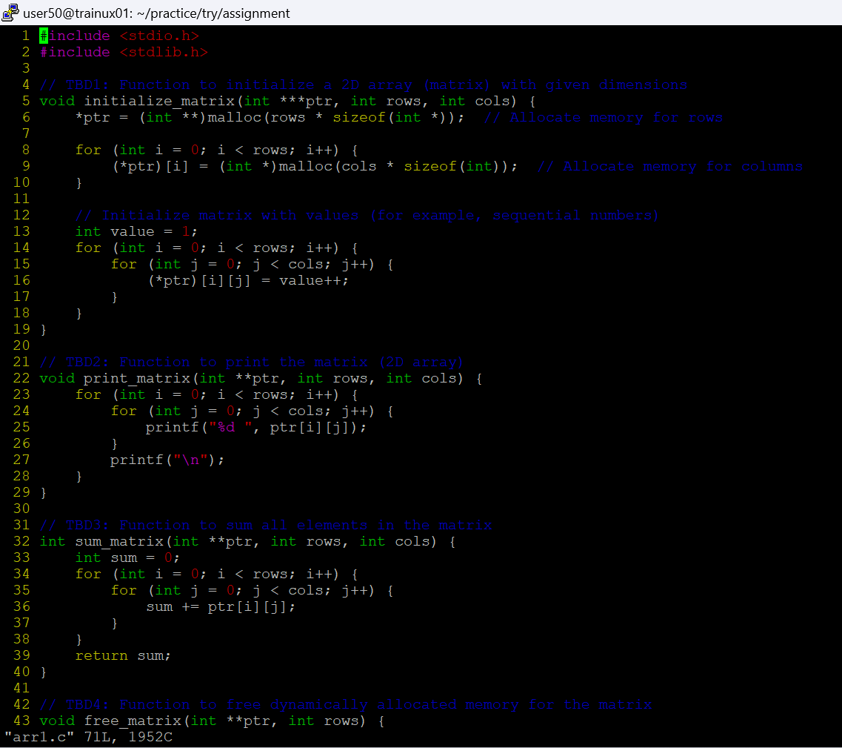

6. Refer the program "pointer_example.c". Fix the warning issue.

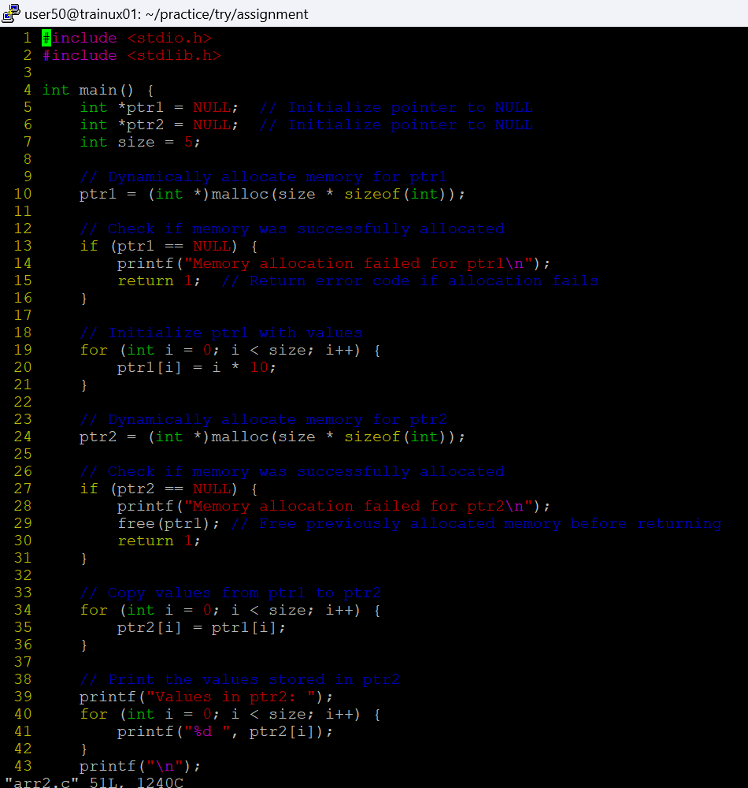

7. Consider an array of strings as below.

char arr[][10]={"Word", "Excel", "PowerPoint", "Pdf", "Paint"};

a. Implement a function read_displaystring() to read a row index from the user, access the string, store in a char * variable and using this, traverse every alternate character in the string and display in console.

void read_displaystring(char *arr[][10], int row);

b. Reverse the string read at the index in a) using a function of prototype as below. Caller to read the returned string and display the reversed string. [Ensure that the input source array is not corrupted and remaining elements are intact]

char *reverse(char *arr[][10], int row);



